**Political Juggernauts A Quantitative Analysis of** **Candidates in the 2019 Lok Sabha Election**

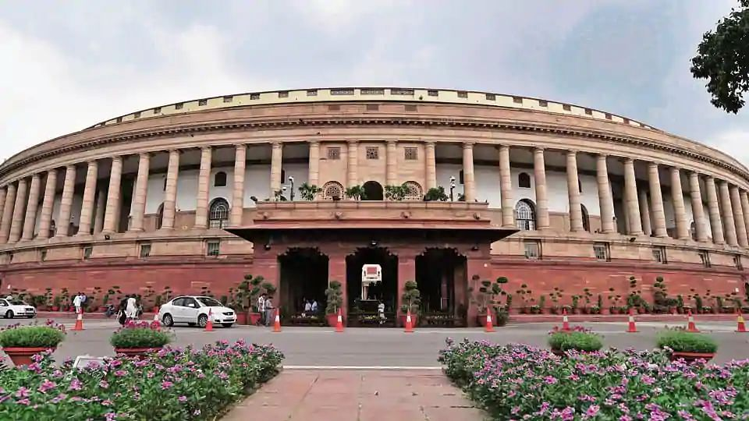

*1.INTRODUCTION*

1.1 OVERVIEW

The lok shaba is composed of representatives of people chosen by direct election on the basis of universal adult suffrage. The constitution of india allows for a maximum of 550 members in the house, with 530 members representing the status and 20 representing the union territories. The 17th lok shaba was formed by the members elected in the 2019 indian general election. Elections, all across india, were conducted in seven phases from 11 april 2019 to may 2019 by the election commission of india.

1.2 PURPOSE

The Bharatiya Janata Party received 37.36% of the vote, the highest vote share by a political party since the 1989 general election, and won 303 seats, further increasing its substantial majority. In addition, the BJP-led National Democratic Alliance (NDA) won 353 seats.

*2.PROBLEM DEFINITION & DESIGN THINKING*

* EMPATHY MAP
* BRAINSTORM

2.1 EMPATHY MAP

* An empathy map is a collaborative visualization used to articulate what we know about a particular type of user.
* It externalizes knowledge about users in order to create a shared understanding of user needs, and aid in decision making. This article is a guide to empathy mapping and its uses.

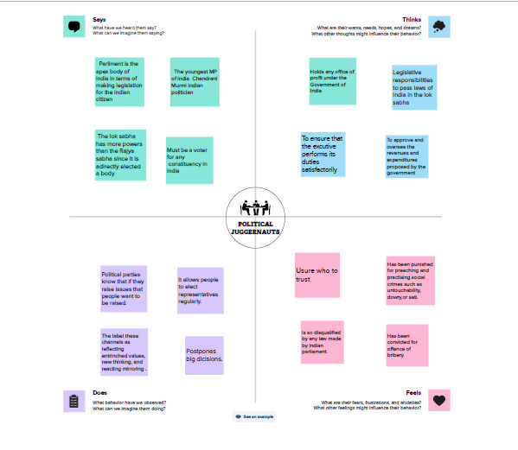

2.2 IDEATION & BRAINSTORMING MAP

* A visualization technique and brainstorming tool which allows you to explore a central idea, and all of its related topics, in a non-linear way.
* When brainstorming , or attempting to see a particular topic from all angles, linear tools-like lists-aren’t always the best solution.

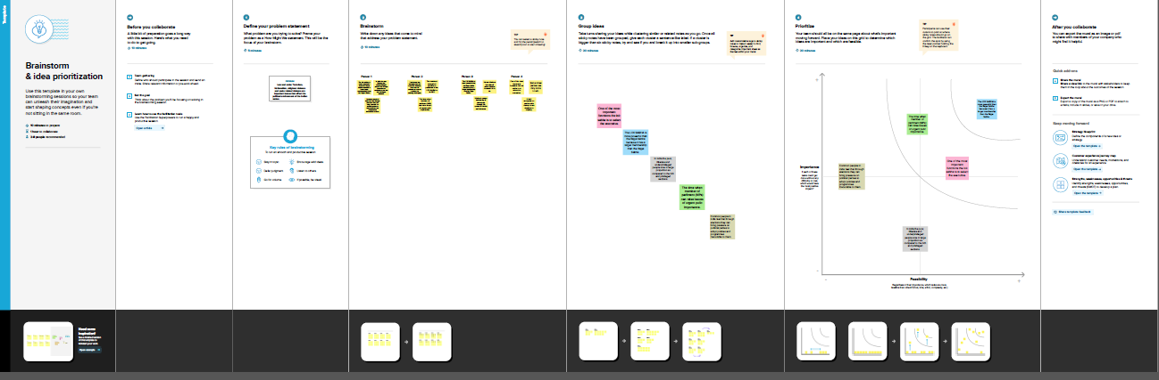

*3.RESULT*

* Collect the Dataset.
* Dataset connect with TABLEAU.

COLLECT THE DATASET

We are collect the dataset in online.

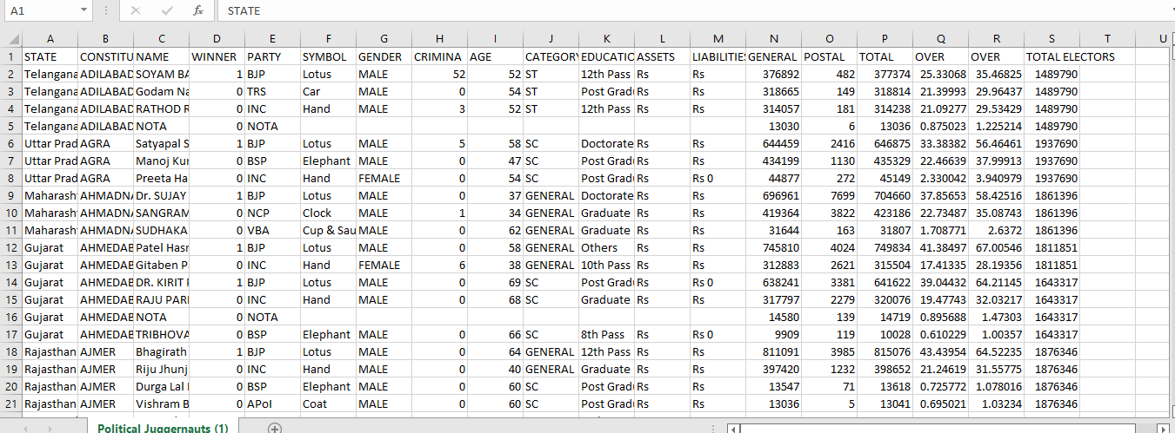

DATASET CONNECT WITH TABLEAU

* Installed the tableau desktop.
* Insert the dataset in tableau.

DATA PREPARATION

* Prepare the data for visualization.
* We give some changes for the dataset.

DATA VISUALIZATION

* We introduced graphical representation to visualization.
* Clear Headings and keys…
* Obvious Trends…
* Simple Analysis…
* Relevant Comparisons…
* Lots of Data/Evidence…
* Summaries of Key Points…
* Add design elements…
* Consolidated Information.

DASHBOARD

* A Dashboard is a graphical user interface (GUI) that displays information and data in an organize.
* Combine two or more sheets create a dashboard.

DASHBOARD 1

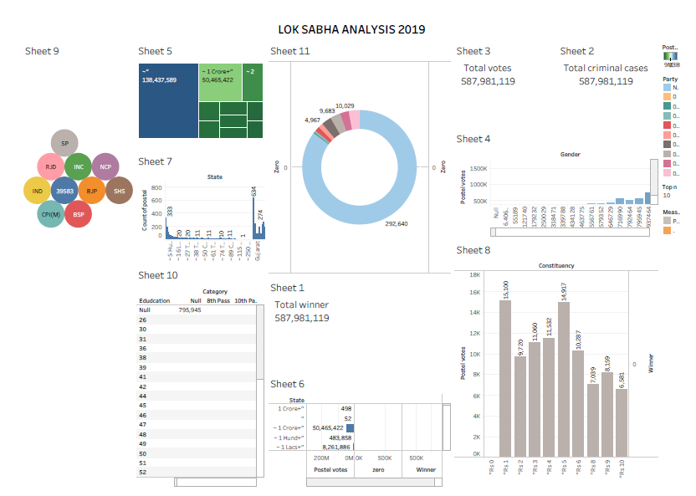

DASHBOARD 2

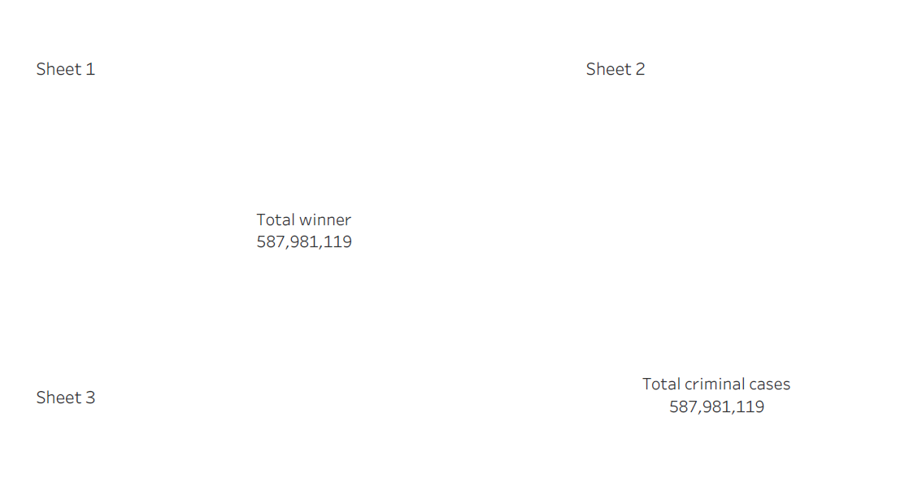

DASHBOARD 3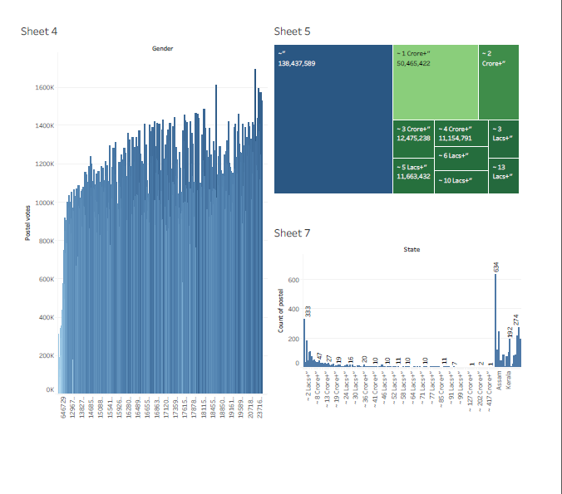

DASHBOARD 4

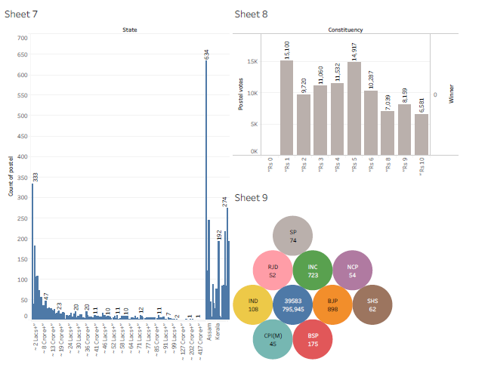

DASHBOARD 5 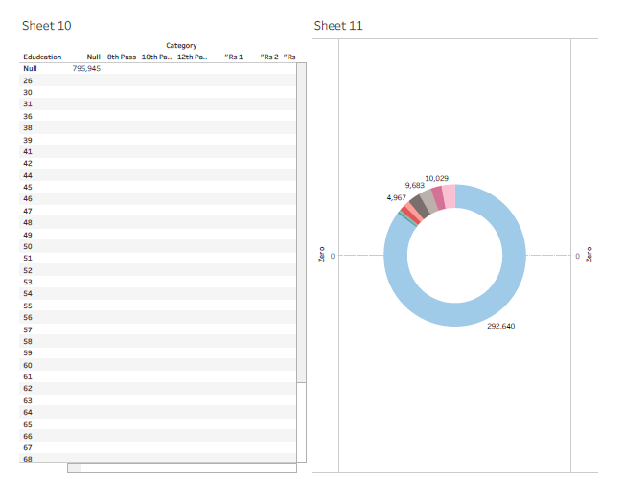

STORY

* A data story is a way of presenting data and analysis in a narrative format, with the goal of making the information more engaging and easier to understand.

STORY CREATION

1. Create story point.
2. Explore layout options.
3. Format a story.
4. Resize captions.
5. Fit the sheets are one by one.
6. Format a story’s shading, title, and text objects.

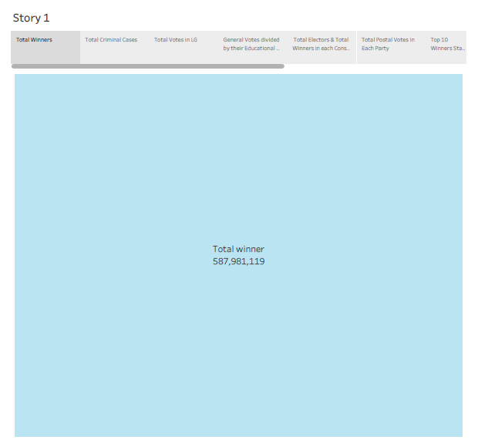

PUBLISHING

Publishing helps us to track and monitor key performance metrics, to communicate results and progress. help a publisher stay informed, make better decisions, and communicate their performance to others.

PUBLISHING DASHBOARD AND REPORTS TO TABLEAU PUBLIC

Step1-Go to Dashboard/story, click on share button on the top ribbon. Give the server address of your tableau public account and click on connect.

Server address-public.tableau.com

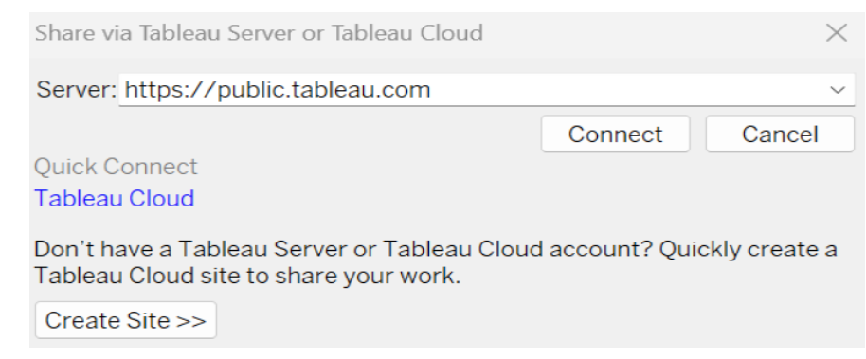

Step 2-Once you click on connect it will ask for tableau public user name and password.

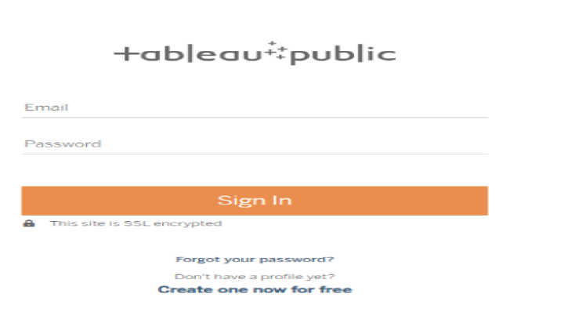

*4.ADVANTAGES & DISADVANTAGES*

ADVANTAGES

* The advantages of an election include the ability for citizens to have a say in who governs them, the opportunity for peaceful transfer of power, and the potential for increased transparency and accountability in government.
* Elections also provide a platform for candidates to share their ideas and policies with the public.

DISADVANTAGES

* The disadvantages of an elections include the possibility of voter fraud and manipulation, the potential for divisive and polarizing campaigns, and the cost and logistical challenges of organizing and conducting an election.
* Additionally, some individuals or groups may not have equal access to the ballot or may face barriers to participating in the election process.

*5.APPLICATIONS*

Create and manage solution records within a service Desk environment. It is the administrative application and is separate from the search solutions application that customers use to find solutions.

*6.CONCLUSION*

A conclusion is the final piece of writing in a research paper, essay, or article that summarizes the entire work. The conclusion paragraph should restate your thesis, summarize the key supporting ideas you discussed throughout the work, and offer your final impression on the central idea.

*7.APPENDIX*

SOURCE CODE

As regards non-compliance by state Government and other authorities with the instructions issued by the Government of India from time to time, the Cabinet secretary stated that fresh instructions could be issued or in the alternative, if the committee made certain suggestions, the same could be taken into consideration by the Government.

DASHBOARD:

<https://public.tableau.com/views/DASHBOARD1_16957149950560/Dashboard1?:language=en-US&publish=yes&:display_count=n&:origin=viz_share_link>

STORY:

<https://public.tableau.com/views/LokSabhaAnalysis2019storyboard/Story1?:language=en-US&publish=yes&:display_count=n&:origin=viz_share_link>